Road blocker TDZ-Z758

1.Introduction

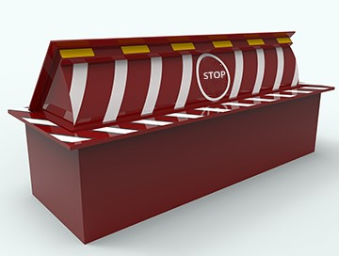

The roadblock machine is also known as the anti-terrorist wall. According to the needs of users, it is divided into roadblocks with spear point and roadblock without spear point. It consists of a fixed frame, a turning body, a hydraulic power system and an electrical control system.
Generally used in important departments such as troops, logistics warehouses, nuclear power plants, military bases, and governments. Used to protect regional safety and prevent violent intrusion of foreign vehicles.

2.Basic parameters

Rise time： | 1-3s adjustable
Fall time： | 1-3s adjustable
Size : | 3000*1000*750mm（length can customized ）
Rising height : | 500mm
Spike specifications | Diameter:30mm* 80mm length
Embedded depth | Device height+ Panel thickness
Panel thickness | 16、20、25mm
Material | A3 steel
Color | Yellow+block, green+ yellow, red+yellow
Drainage design | Effective drainage at the bottom of the fuselage
Anti-rust treatment | Using spray paint technology, with anti-rust ability
Warning sign | With obvious warning signs, with night warning function

3.Control unit

The electrical accessories used in the control unit are all first-line brands
The control box is designed with waterproof structure and can be used purely outdoors. The surface is treated with powder spraying, rust-proof and beautiful. The main control program has powerful functions, stable performance and strong system linkage.
The control system's anti-electric strength, insulation resistance, leakage current, electrostatic discharge immunity, electrical fast transient pulse group immunity, and surge (impact) immunity are all in line with GA/T1343-2016 standards.

Control system ： | Xinje PLC American original chip
Control box： | Powder spraying process for pure outdoor use with LCD display
Self-test program： | Standard
Trial period setting： | Standard
Dark and bright settings： | Standard
Public security linkage： | Standard
Fire linkage： | Standard
Air leakage switch： | Zhengtai
Contactor： | Zhengtai
Relay ： | Omron
Power supply： | Taiwan Mingwei 220VAC (industrial grade)
Remote control ： | 100m
LED remote control ： | 2.4G 30m
Wire control switch： | optional

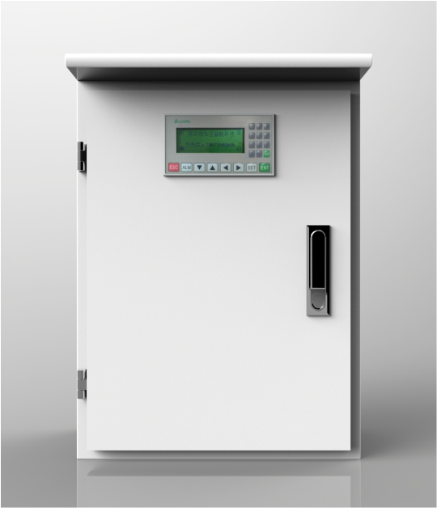

4.Power unit

Power unit： | Electro-hydraulic
Motor： | 3HP*4P，Three-phase 380VAC (industrial grade）
Oil pump: | Gear pump (industrial grade)
Hand pump： | Standard (emergency lifting)
Fuel tank capacity: | 30-60L
Tubing： | PT international standard interface, 1/2 double-layer steel wire high pressure pipe
Protection level： | IP67
Power supply： | 380VAC（control power 24VDC）
Power ： | 3.75-5.5KW
Cylinder end buffer： | Stable lifting and low noise
Working temperature ： | -35℃~75℃
Traffic pressure: | 0-100 ton container truck

5.System composition
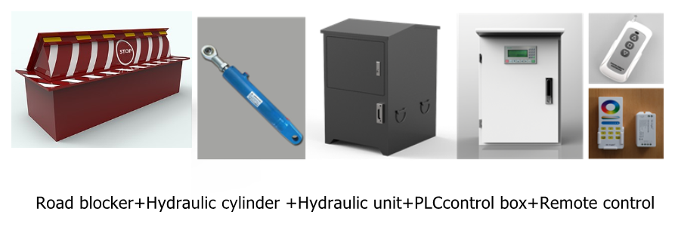

6.Product performance

-Unique hydraulic buffer technology at the end of the lift, stable operation and low noise.
-Adopt PLC system control, stable, reliable and easy to integrate.
-It can be linked with other systems such as barriers, ground sensing, infrared, etc. to realize intelligent control.
-In the state of power failure, the roadblock supports manual lifting.
-The control system complies with the GA/T1343-2016 standard.
-The panel is formed in one piece, no welding process, beautiful, strong and anti-collision.
-The surface is treated with marine paint for anti-rust, and high-gloss reflective stickers are used to play the role of beauty and warning.
-Optional LED lights, the night warning effect is more obvious and more beautiful.
-Anti-collision rating: K12 (the vehicle is damaged when it hits at a speed of 120 kilometers per hour)

- Application scenarios

Public security checkpoints, prisons, detention centers, oil depots, grain depots, reservoirs, natural gas depots, treasurys, military, fire stations, police stations, public security bureaus, security bureaus, parks, urban traffic, etc.

8.Wire diagram
